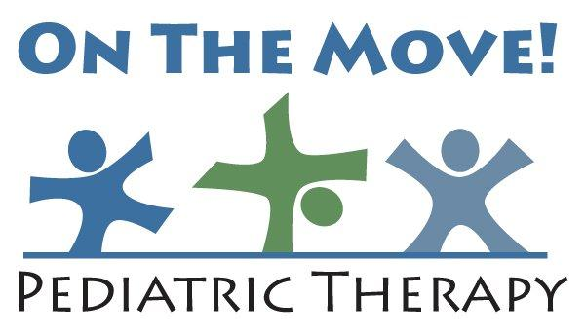

Statement of Client Rights
All clients receiving services from On The Move Pediatric Therapy have the following rights:
1. The right to receive individualized treatment
2. The right to file a grievance, recommendation, or opinion regarding the services the client receives
3. The right to give informed written consent regarding participation in a research study with the exception of a child whose parent or guardian shall give informed written consent
4. The right to confidentiality of all health information, as regulated by HIPAA
5. The right to request a written statement of the charge for a service and be informed of the policy for the assessment and payment of fees
6. The right to be treated with consideration, respect, and personal dignity
7. The right to review your client record in accordance with OTM’s policies
8. The right to receive one free copy of your client record

